

DOKUZ EYLUL UNIVERSITY ENGINEERING FACULTY DEPARTMENT OF COMPUTER ENGINEERING

CME1252 PROJECT BASED LEARNING – II

FINAL REPORT

PROJECT – II

POST-FIXER

By

Sadullah CİHAN

Simay AYBERİK

Samet KERVAN

Lecturers

Lecturer Özlem AKTAŞ

Res. Asst. Özge KART

April, 2020

İZMİR

Page

CONTENTS

CHAPTER ONE

INTRODUCTION 1

CHAPTER TWO

PROJECT DESCRIPTION 2

CHAPTER THREE

TASK SUMMARY 3-5

3.1. Completed Tasks 3-4

3.2. Incomplete Tasks: Reasons and Explanations 5

3.3. Additional Improvements to the Project 5

CHAPTER FOUR

ALGORITHMS AND SOLUTION STRATEGIES…………………………….6-7

CHAPTER FIVE

PROBLEMS ENCOUNTERED AND CHANGES IN REQUIREMENTS 8

CHAPTER SIX

OVERALL ASSESSMENT OF THE PROJECT 9

REFERENCES 10

POSTER OF THE PROJECT…………………………………………………….11

TRELLO MESSAGES…………………………………………………………12-14

CHAPTER ONE

INTRODUCTION

This is the CME1252 PROJECT BASED LEARNING lesson’s second project’s final report of Dokuz Eylül University of Computer Engineering department. The project period is 5 weeks. The aim of the project is to develop a one-player game about postfix expressions.

1

CHAPTER TWO

PROJECT DESCRIPTION

The game is played on a 10x10 board. Board elements are numbers (1-9) and 4 operations (*, +, /, -). These elements are added to the game from an input queue. The aim of the game is to form postfix expressions by using board elements and getting the highest score.

2

CHAPTER THREE

TASK SUMMARY

3.1 Completed Tasks

Sadullah CİHAN:

It is organized the team for an online-meeting. It is created the necessary classes and variables for the project. For instance, Game, Stack [1], Circular Queue [2], and Main classes have been created. Also, “free mode”, “take mode” with proper time, “expression for score calculation”,”evaluation mode”, methods has been implemented. The program has been tested correctly without bugs, design errors. All things to be done are accomplished on time. You can see task-date table on FIGURE-1. The project team occur 3 report authors.
Task / Date | Week One | Week Two | Week Three | Week Four | Week Five
Design of classes, Creating | March 9-15
screen, time countdown | All team.
Board with random elements, |  | March 23-29
cursor movement, expression |  | Sadullah Cihan,
score calculation |  | Samet Kervan
“Free mode”, “Take mode” |  |  | March 30-April 5
without proper time flow |  |  | All team.
Free mode, Take mode with |  |  |  | April 6-12
proper time flow. |  |  |  | Sadullah Cihan
Expression evaluation mode |  |  |  |  | April 13-17
 |  |  |  |  | Simay Ayberik

FIGURE-1 The first column represents the whole task which were accomplished. The first row represents the project’s weeks. The diagonal informs dates, shows who worked on the planned work until the end of the project. Cause of postponing the second week of the project will be explained in chapter five.

3

Simay AYBERİK:

Scorefactor of the postfix expression has been calculated and added to the total score. Expression evaluation mode has been finished without checking if it is the proper postfix expression or not.

Debugging has been done on "take mode". Score and evaluation steps with stack [1] have been added to the "print screen" function.

Samet KERVAN:

Free mode, movement, filling input queue with random symbols, placing symbols to the screen from input queue, screen and game arrangement have been completed. Some sample bugs are fixed.

4

3.2 Incomplete Tasks: Reasons and Explanations

Sadullah CİHAN:

All things to be done are accomplished. There is no uncompleted task.

Simay AYBERİK:

Project is completed.

Samet KERVAN:

There isn't any incomplete tasks.

3.3 Additional Improvements to the Project

Sadullah CİHAN:

In evaluation mode, if the taken expression invalid, the evaluation mode will not work. This improvement helped the algorithm efficiency.

Simay AYBERİK:

Simplification has been done for the evaluation part to make the process

faster.

Samet KERVAN:

It has been implemented extra keybord button for cursor movement. For instance, you can go right with pressing D or right arrow.

5

CHAPTER FOUR

ALGORITHMS AND SOLUTION STRATEGIES

Sadullah CİHAN:

Firstly, It is discussed with project teammates to create solution strategies. Then, it has been done the research. Filling a random two-dimensional screen array algorithm is implemented simply. Two random numbers are created then, the array is filled with random elements.

Secondly, “free mode” contains cursor movement. The significant part of this method is that if the cursor is in boundary, the cursor has been stopped.

Thirdly, designing “take mode” algorithm took exactly two days. In one while loop, firstly it is checked which keyboard direction. Then cursor has moved that direction. If the character is an operator, it has been enqueued to expression queue. If characters numbers, they are concatenated with string structure in one another while loop. Then the number is enqueued in the expression queue.

Fourthly, time cutdown has been created with Thread.sleep() function. It is working with 20 ms. Hence, time is decreasing one by one due “counter % 50 == 0” condition. The cause of 50 is 20ms X 50 = 1000 ms. This equals one real second.

Lastly, in the evaluation mode, the program counts operators amount and numbers amount. Unless operators amount equals to a minus of numbers amount, given expression is not valid and the program will not continue. On the other hand, if the given expression is valid, the program pushes two elements to stack. After that takes from the stack and looks at the following operator. The expression is evaluated according to the operator and is pushed back to the stack.

6

Simay AYBERİK:

Dividing the function parts is needed for the effectiveness of code, it made the algorithm look more simple and understandable, besides the score factor calculation and evaluation mode functions have been used in "take mode" function. Enigma library helped with the window generation and effective usage for cursor movements.

The essential principle of evaluation mode firstly leans on checking the counters of numbers and operations. Secondarily the algorithm is based on controlling the stack size which we used for calculation whenever we pull another operation symbol.

Samet KERVAN:

Movement: Whenever the any of the movement keys are pressed the program moves the cursor that direction than checks the cursor position and if it is outside the borders it puts it back to the border.

Screen arrangement: The program firstly fills the input queue with random elements until the symbol count is ten. Then selects a random place from the screen then checks to see if it is empty. If it is not empty then it selects another coordinate(x,y). If it's empty then places the symbol there. Repeats this steps till the symbol count at the screen is forty. Whenever the input queue is empty it fills it again.

Game arrangement: The time only moves at the take mode. When the timer hits zero the gameOver variable becomes true. When the variable turns to true the program exits the take mode and the game ends.

7

CHAPTER FIVE

PROBLEMS ENCOUNTERED AND CHANGES IN REQUIREMENTS

Sadullah CİHAN:

The first problem that the project team encountered is the break of all university due to COVID-19. Thus, the second week of the project is postponed one week and the project team cannot be done face-to-face meeting. However, it has been fixed with an online meeting.

The second problem that the project team encountered is creating unnecessary classes. It is obvious that “operations” have to be a method. That is why all main structure has been changed. Also, new structure and methods are tested. It is working successfully without bugs.

The third problem that the project team encountered is expression’s structure was a stack[1]. This structure is not efficient with using the expression. Thus, it has been changed with the circular queue[2].

Simay AYBERİK:

The stack data structure [1] has been used for expression which we kept digits, numbers and other operations firstly, this situation caused a lack of adjusting the functions and it slowed the process of completing the code. In evaluation mode revealing old numbers and updating them with the new ones was hard at first , it has taken so much time while controlling it.

Samet KERVAN:

In the take mode taking multiple inputs was challenging. I tried to make it with multiple ifs but it became too complicated. Then another member of the group made it with the while loop. It had some problems first like not taking multiple digit numbers correctly when they are approached from below or top. But they are fixed now. Another problem was the game was entering infinite loop while filling the screen. When the function is changed this problem is also solved.

8

CHAPTER SIX

OVERALL ASSESSMENT OF THE PROJECT

The project is accomplished successfully. All things that take part in the plan is accomplished on time. Finally, the project is delivered.

9

REFERENCES

1- Stack, Dave L., Retrieved 9 March 2020 from https://stackoverflow.com/questions/38678268/stack-implementation-in-java

2- Circular Queue, Danislav Lyubenov, Retrieved 20 March 2020 from https://stackoverflow.com/questions/43156773/circular-queue-array

10

APPENDIX A

POSTER OF THE PROJECT
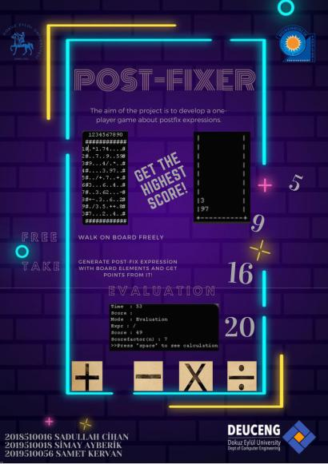

11
APPENDIX 2: TRELLO MESSAGES
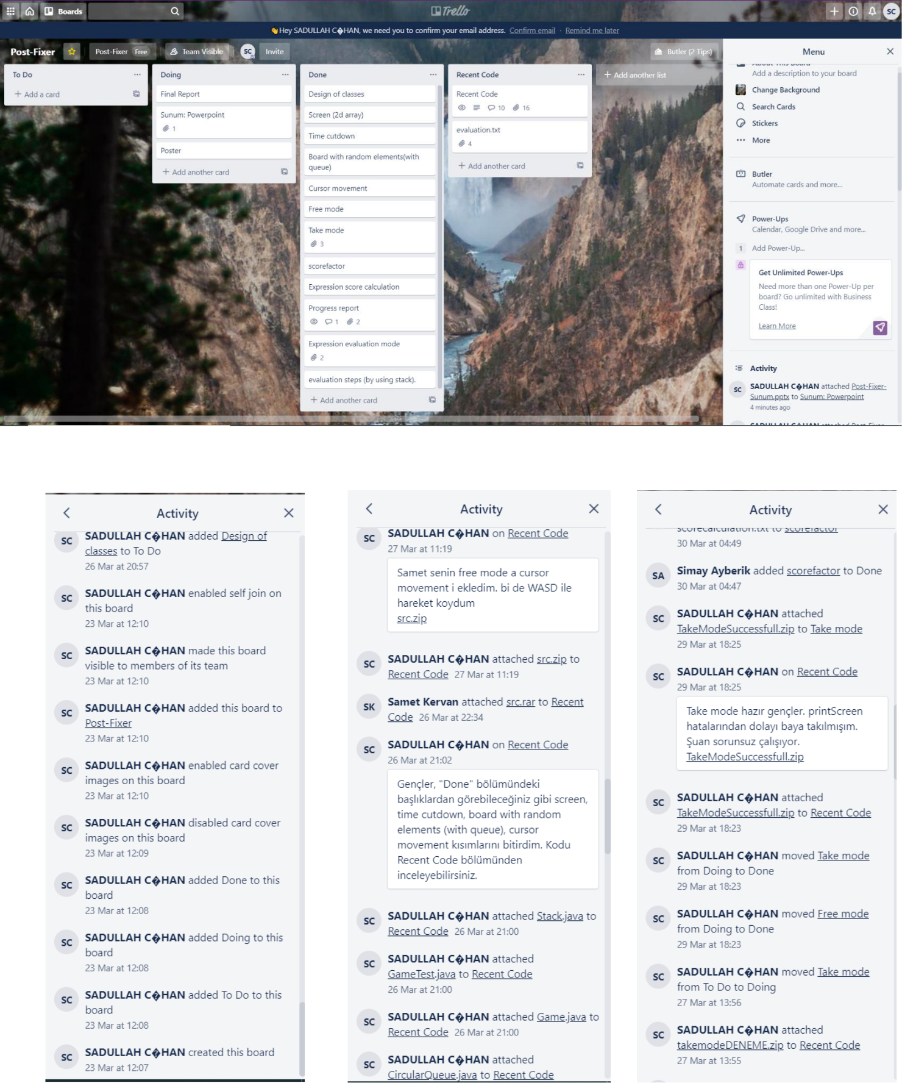

12

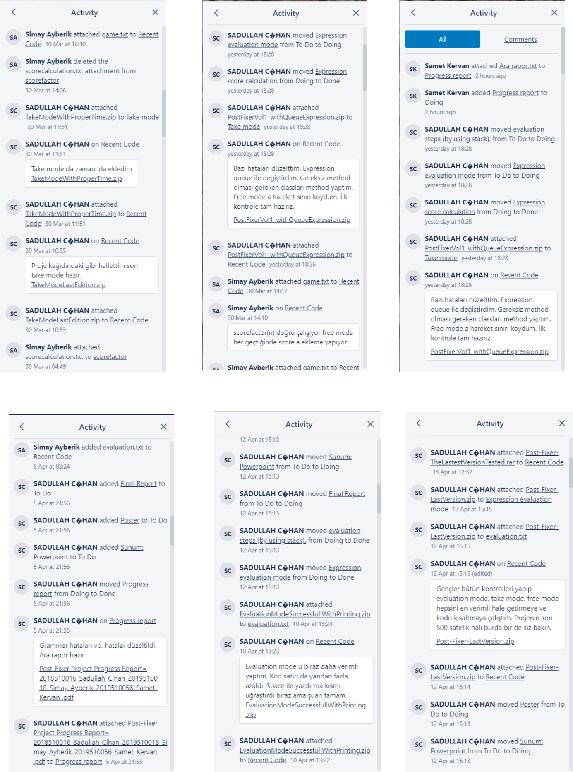

13
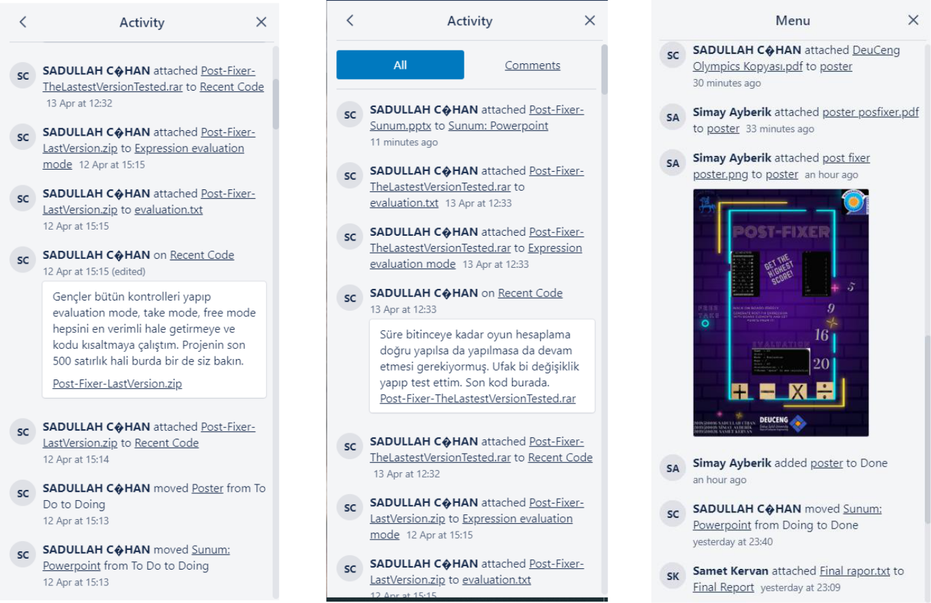

14

